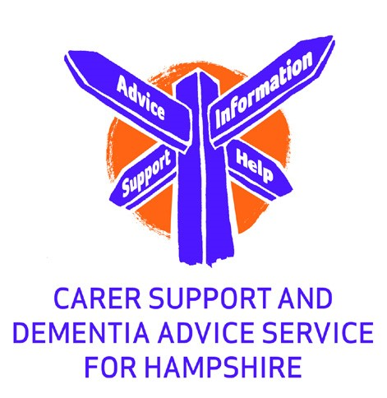
Friends of Fareham Community Hospital
Dementia Drop-in Support Groups
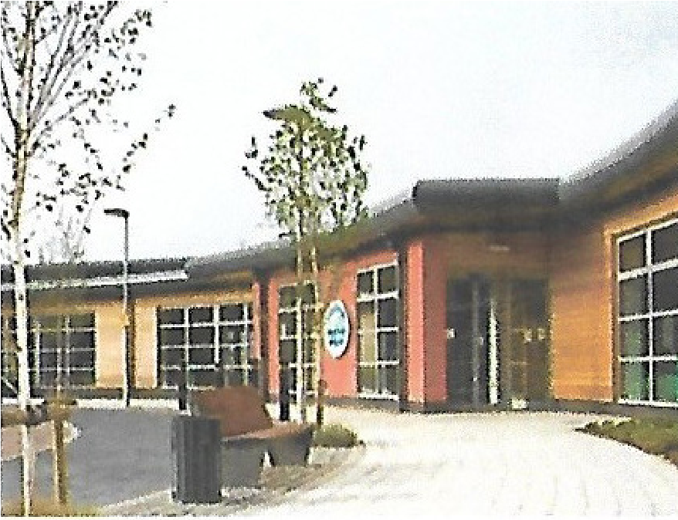
A free service is available for people with any type of dementia and for their carers and families to attend for support and friendship.
A Dementia Adviser is present and available for individual appointments to be made. They can also signpost
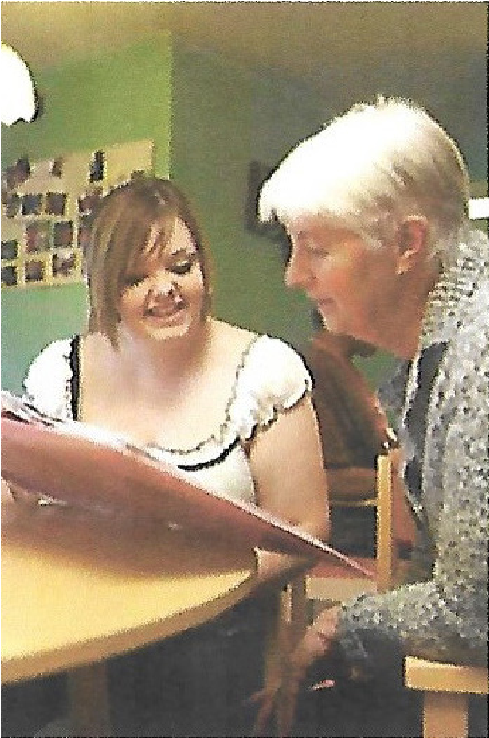
you to services in your local area.
Held every Monday
10:30 am to 12:30 pm
And
1:00 pm to 3:00 pm
At the Park Gate
Royal British Legion Club
366 Brook Lane
SO31 7DP

Refreshments and support by
Friends of Fareham Community Hospital Volunteers
and
Carer Volunteers

For more information call Petta on 01489 584 086

or for an appointment with the Dementia Adviser
call 01264 332297

website: www.friends-of-fch.org

